**PYTHON COMPETATIVE CODING**

**Python Internship**

**BACHELOR OF TECHNOLOGY**

**IN**

**ELECTRICAL AND ELECTRONICS ENGINEERING**

Submitted by

Kata Jayasri

21kq1a0212

Under the Mentorship of

**Shravan Mantri**

** Technical Trainer**

**DEPARTMENT OF ELECTRICAL AND EL ECTRONICS ENGINEERING**

PACE INSTITUTE OF TECNOLOGY AND SCIENCES (AUTONOMOUS)

(Affiliated to Jawaharlal Nehru Technological University Kakinada, Kakinada &

Accredited by NAAC ‘A’ GRADE, An ISO 9001-2015 Certified Institution)

NH-16, Valluru Post , Prakasam District, A.P-523272.

(2023-2024)

**SCHOLASTIC ACHIEVEMENTS DASHBOARD**

**Date :- 10th June 2024**

**Submitted by :- Jayasri kata(21kq1a0212)**

**Details of Project :- I’m implementing this project by using Python Programming Language**

**Description :-**

The purpose of the Scholastic Achievements Dashboard project is to provide an efficient and effective tool for managing and analyzing academic data within educational institution. The Scholastic Achievement Dashboard project is designed to provide a comprehensive overview of students' academic performance and progress. It typically includes features such as tracking grades, attendance records, test scores, and other relevant academic data. It can be a valuable tool for enhancing communication between teachers and students regarding educational outcomes and areas for improvement.

**Requirements** :

User Authentication : User should be able to login to see the details.

Folder : A Folder which consist of student academic details in a proper order.

(Roll number, student name, marks of particular subject, Total…… etc)

Folder Updating : Updating the data in the folder as per the updated mark.

Data Verification : Verification of the data in the folder as per the roll number in proper

format.

Comparative Analysis: Comparing average of student with the remaining students.

Dashboard display : A dashboard to show the highest performance of the students.

Security : Implement security measures to protect student data, such as user

Authentication, data encryption.

**Project approach:-**

1. **Design Data Structure:**
   * Define a dictionary structure to store student information.
   * Each student will have attributes like name, roll number, marks, and total marks.
2. **Implement Functions:**
   * add_ student (name, roll _number, marks): Function to add a new student record.
   * display_ student_ records(students): Function to display all student records.
   * Calculate _statistics(students): Function to calculate total, highest, and lowest marks.
   * search_ student (students, name): Function to search for a student by name.
   * sort _records(students): Function to sort student records alphabetically.
3. **User Interface:**
   * Implement a command-line interface for user interaction.
   * Provide options for adding new student records, displaying records, searching for a student, and sorting records.
4. **Error Handling:**
   * Implement error handling for invalid user input (e.g., non-integer marks).
   * Handle exceptions gracefully to ensure the stability of the application.
5. **Testing:**
   * Test the application with different scenarios, including valid and invalid inputs.
   * Ensure that all functions produce the expected output and handle edge cases appropriately.
6. **Documentation:**
   * Document the project with clear comments and docstrings for each function.
   * Provide a user guide explaining how to use the application and its functionalities.
7. **Optimization:**
   * Optimize the code for efficiency, especially for large datasets.
   * Consider using libraries like Pandas for data manipulation if needed.
8. **Deployment:**
   * Package the application for distribution.
   * Provide clear instructions for installing and running the application.

9. **User Training and Support:**

* + Provide user training sessions to familiarize users with the application and its features.
  + Offer ongoing support and maintenance to address user inquiries, issues, and feature requests.

**Project code :-**

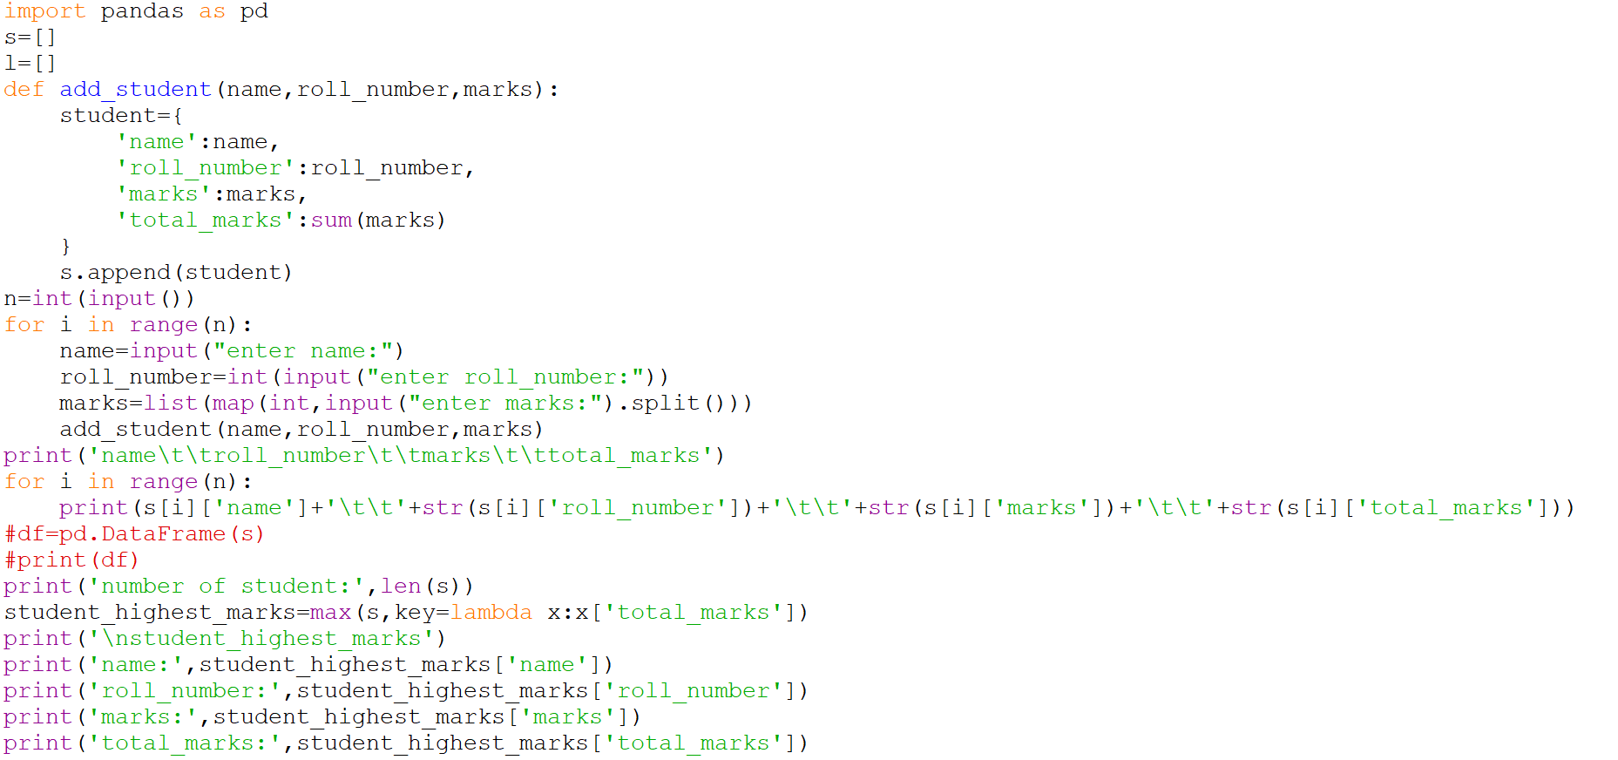

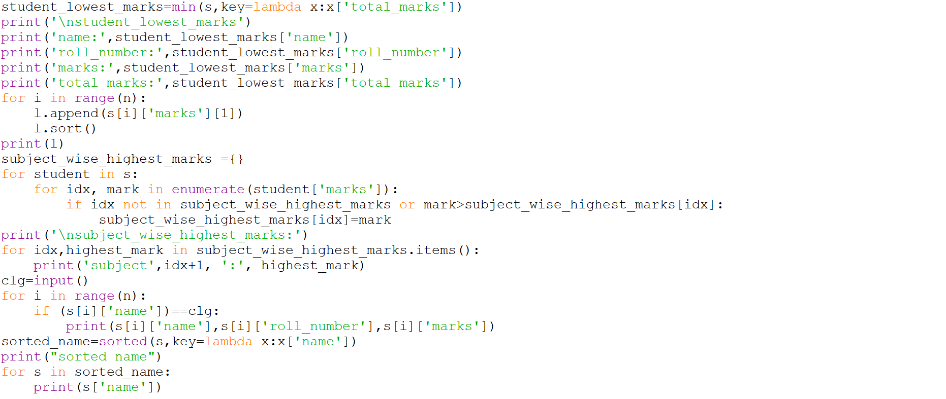

**Output:-**

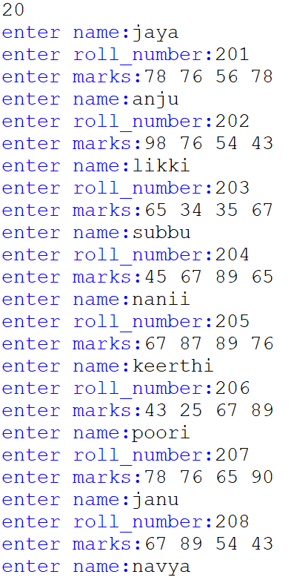

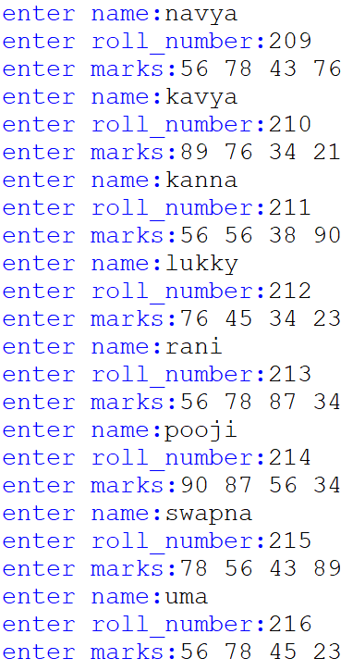

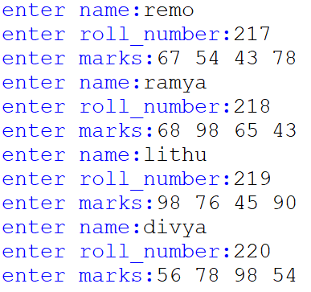

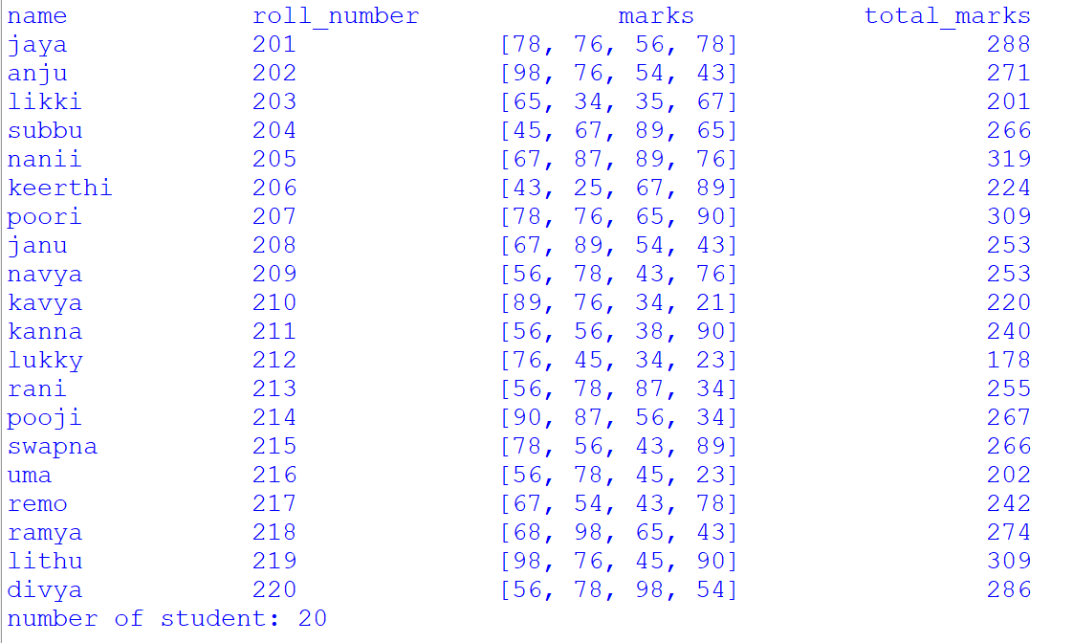

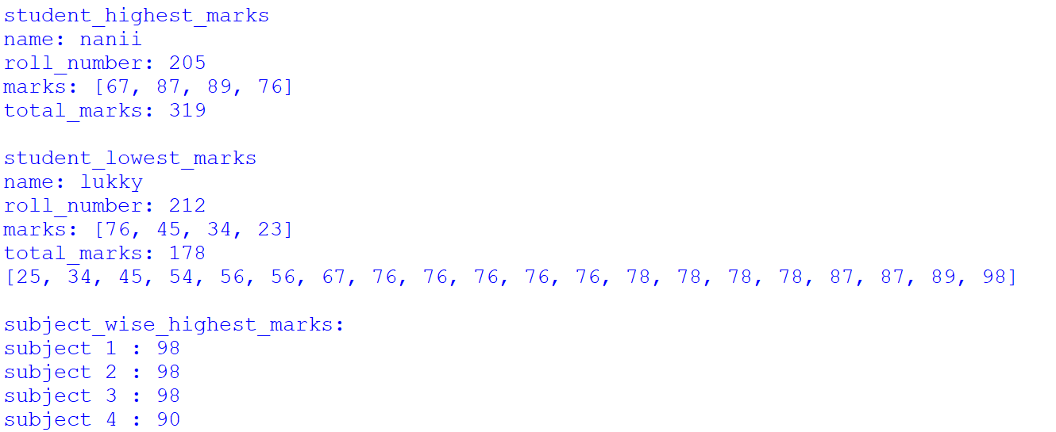

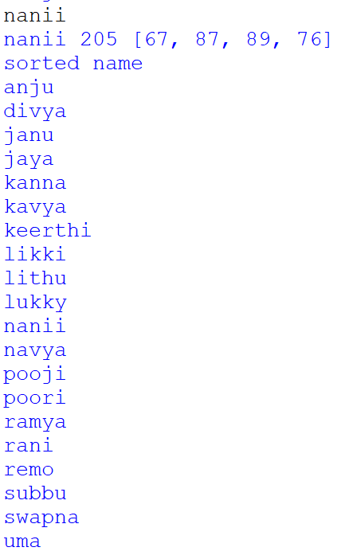

Explanation:-

• **Importing Libraries**: It imports the pandas library as pd.

• **Initializing Lists**: Two lists are initialized, s for storing student data dictionaries and l for storing marks of third subjects across students.

• **add _ student Function**: This function takes three parameters - name, roll number, and marks. It creates a dictionary representing a student's data and appends it to the s list. It also calculates the total marks for each student.

• **Input Section**: It takes input for the number of students (n) and then iterates n times to take input for each student's name, roll number, and marks for different subjects.

• **Printing Student Data**: It prints the student data in a tabular format, including name, roll number, marks, and total marks.

• **Calculating Statistics**: It calculates and prints the number of students, student with the highest marks, student with the lowest marks, marks of the third subject sorted in ascending order, and subject-wise highest marks.

• **College Search**: It takes input for a college name and prints the details of students belonging to that college.

• **Sorting by Name**: It sorts the student data by name and prints the sorted names.

**Conclusion :-**

The provided Python code manages student data by storing information such as name, roll number, and marks for multiple students. It calculates various statistics like total marks, highest and lowest marks, subject-wise highest marks, and sorts student data by name. Additionally, it allows users to search for students based on a specified college name. However, the code could be further improved with error handling, such as input validation, and more modularization for better readability and maintainability.

THANK You